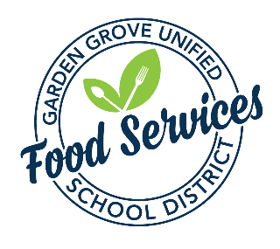
  - Asian Take-Out Order Form 26.27
Three weeks (15 business days) is required
Please email this form to:

Arielle Sutherland asutherland@ggusd.us and Leo Bas lbas@ggusd.us
CC: Ofelia Visoso ovisoso@ggusd.us

Meal Price: No cost to GGUSD Students $8.00 per adult / per non GGUSD Sibling

1. Name of school and contact info
School:
Contact Name /E-mail: phone ext:
Revised ☐ check if this is a revision to a previous Asian Take-Out party
Menu:
* Orange Chicken and White Rice
* Assorted Fruits & Veggies
* Juice
* Milk
* Fortune Cookie

2. Day & Date of Asian Take-Out party (ex: Monday, August 15)
Click here to enter a date.

3. Serving Time

4. Number of 5. Number of adults & non GGUSD
students participating siblings participating

6. Total number requested (4+5)

7. Will the school site pay for the adults & siblings? Yes ☐ No ☐
8. Is this an all school party? Yes ☐ No ☐
FOOD SERVICES USE ONLY
E-mail completed form to: Operations Manager, Central Kitchen Manager (forward to Lead), and Site Secretary.
Date order taken from school
Number of Servings Ordered
Central Kitchen
Order Taken By
Order Sent
Operations Manager

School’s Responsibilities:
* Custodian arranges for adequate number of trash cans & tables in the eating and service areas.

** School to pre-sell tickets for all adults & siblings participating prior to Asian Take-Out party

This institution is an equal opportunity provider.

